ASX/AIM RELEASE
6 FEBRUARY 2024

Mineral Resource update for Sagay

Mining Project

HIGHLIGHTS
- Focus of the update related to shallow supergene copper mineralisation which now includes Measured and Indicated Mineral Resources.
- Combined Measured, Indicated and Inferred Mineral Resource of 312 million tonnes @ 0.39% copper and 0.11g/t gold.
- Global Resource remains largely unchanged with ~1.2 million tonnes of contained copper and ~1 million ounces of contained gold.
- The copper mineralisation remains open in multiple directions, with further shallow targets untested.
- Mineralisation exists from near surface down to over 1.2km depth with strike lengths up to 1km and true widths extending into the 100’s of metres.
______________________________________________________________________________
Celsius Resources Limited (“Celsius” or “the Company”) is pleased to announce an updated JORC compliant Mineral Resource estimate (“MRE”) for the Sagay Copper Project (“Sagay” or “Project”), held under its Philippine Subsidiary, Tambuli Mining Company, Inc (“TMCI”) and located at the Island of Negros in the Philippines.
The update to the MRE at Sagay is largely based on the results from the 2023 drilling program at a shallow copper position located ~500m to the west of the main body of mineralisation discovered to date, as announced on 17th October 2023. This shallow copper zone offers Celsius the opportunity to investigate a low cost start up opportunity via a feasibility study which has been submitted to the Philippine Government.
Celsius Resources Managing Director, Peter Hume said:
“The greater definition of the shallow supergene copper at Sagay has increased both the Resource category and our own confidence in the ability to look at a new shallow sustainable friendly development option. The previous Mineral Resource only placed this area in the Inferred Category, and with this new update to the Mineral Resource, this area is now largely in the Measured and Indicated category, which allowed us to complete and submit a feasibility study to the Philippine Government.

The Company has taken a sustainable approach to the proposed development of the Sagay Mineral Resource, similar to its flagship MCB project. Eliminating the use of a conventional tailings dam and using the tailings for environmental rehabilitation, along with processing the ore through gravity separation, therefore eliminates the use of chemicals. We are in the process of finalising the Project’s environmental impact assessment which will clearly demonstrate the Company’s commitment to environmental protection and preservation through advanced mining technologies.”

CLA Chairman, Atty. Julito R. Sarmiento added:

“The development of the Sagay Project can assist with meeting the global demand for green metals in an effort to transition to clean energy sources and achieve the global goal of net zero emissions by 2050 to stave off climate change calamity. CLA constantly takes serious efforts to develop genuinely responsible projects by tightening up our environmental managements systems and stepping up our social and environmental performance.”

THE SAGAY COPPER-GOLD PROJECT

Location
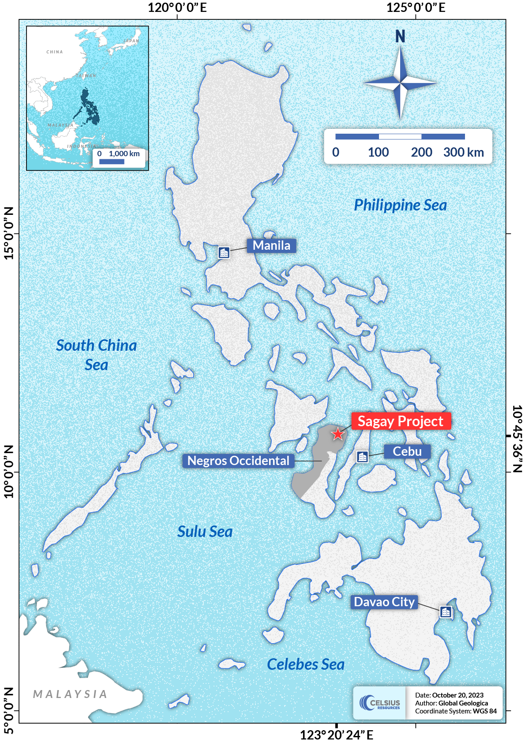
The Sagay Copper Project is in the north-eastern part of Negros Island, within the cities of Sagay and Escalante in the Province of Negros Occidental, Philippines (Figure 1). Negros Island is part of the central group of Islands in the Philippines commonly referred to as “the Visayas”.

Figure 1. Location of the Sagay Copper Project in the Island of Negros, Visayas, Philippines

The MRE for the Sagay Property is located at Purok Tan-ao, Barangay Lopez Jaena (see Figure 2).
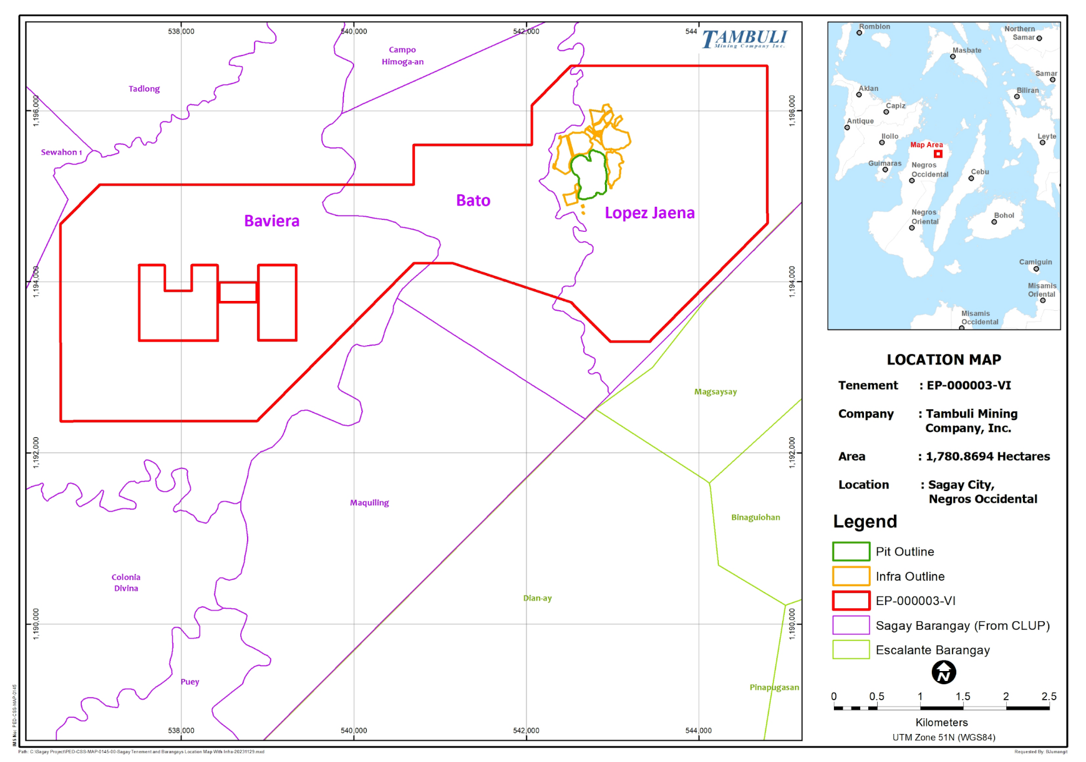

Figure 2. Location of the tenement area of the Sagay Project.

Mineral Resource Estimate
Drilling at Sagay has broadly defined a large-scale copper mineralisation which is interpreted to be a typical porphyry copper style of mineralisation, common throughout the Philippine archipelago.
The copper mineralisation for the MRE at Sagay is defined by three defined mineralised domains, two of which (namely 100LG and 100HG) relate to a main body of copper mineralisation which exists underneath a local topographic high.
This topographic high relates to Purok Tan-ao with resistive siliceous rocks interpreted to be an eroded lithocap associated with the porphyry mineralisation.
A third mineralised domain (900SG) hosts a shallow flat lying supergene copper mineralisation towards the west of the main mineralisation underneath Purok Tan-ao and is possibly related to a satellite porphyry mineralisation. Figures 3 to 7 show a plan view and cross sections of the mineralised domains relative to the host rock geology.
The copper mineralisation at Purok Tan-ao is broadly constrained by a zone of mineralisation which exceeds 0.2% copper and is trending parallel to the main alteration and related intrusive host rocks.
A lower cut-off grade of 0.2% copper was applied in the reported MRE (summarised in Table 1) which aligns broadly with the expected economic limits of the likely mining and processing options considered at Purok Tan-ao.
Table 1: Summary results for the Mineral Resource estimate at Purok Tan-ao at a cut-off grade of 0.20% copper.
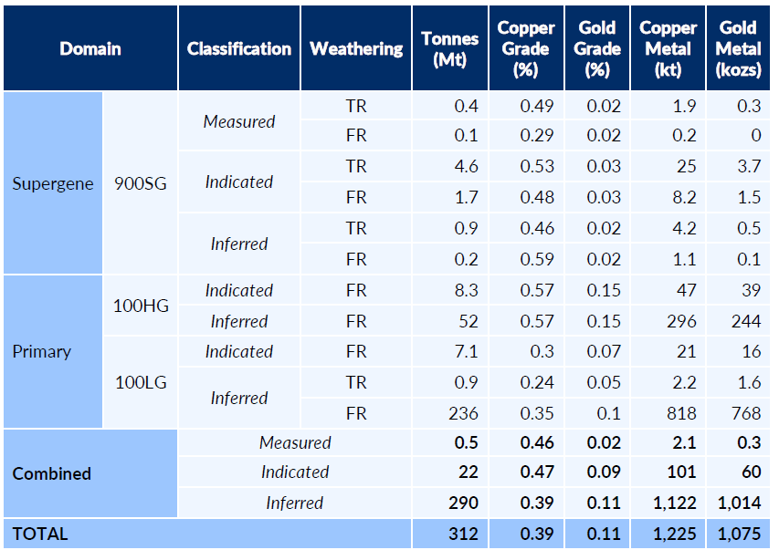
Note for table of results: Calculations have been rounded to the nearest Mt of ore (to the nearest 100,000t where <10Mt), two significant figures for Cu and Au grade and to the nearest kt of Cu metal and kozs of Au metal (to the nearest 100t where <10kt). Some apparent errors may occur due to rounding. TR – Transition or partially oxidised Rock, FR – Fresh Rock.

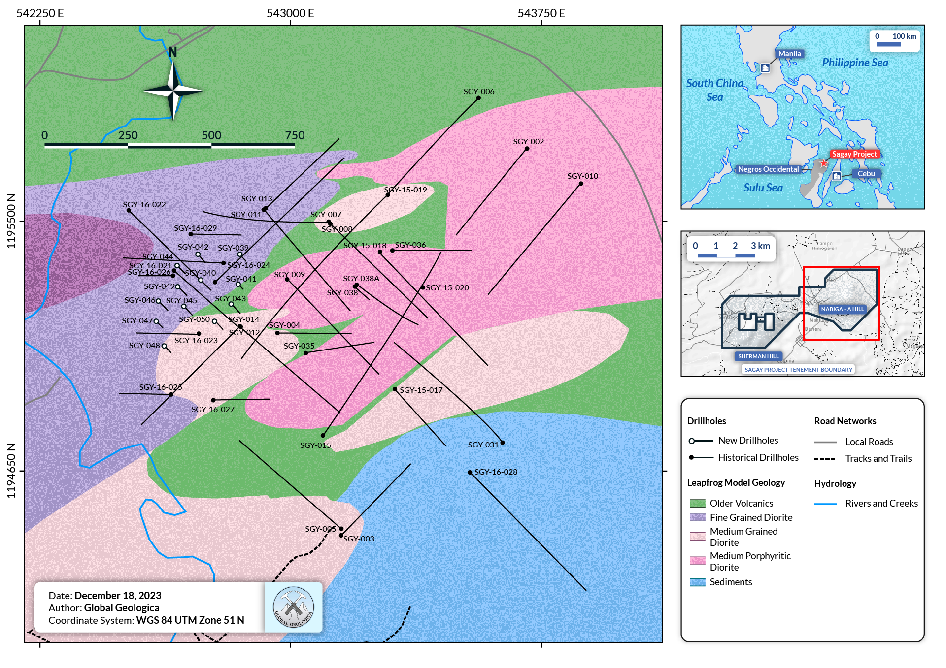

Figure 3. Drill hole locations and interpreted surface geological plan view diagram.
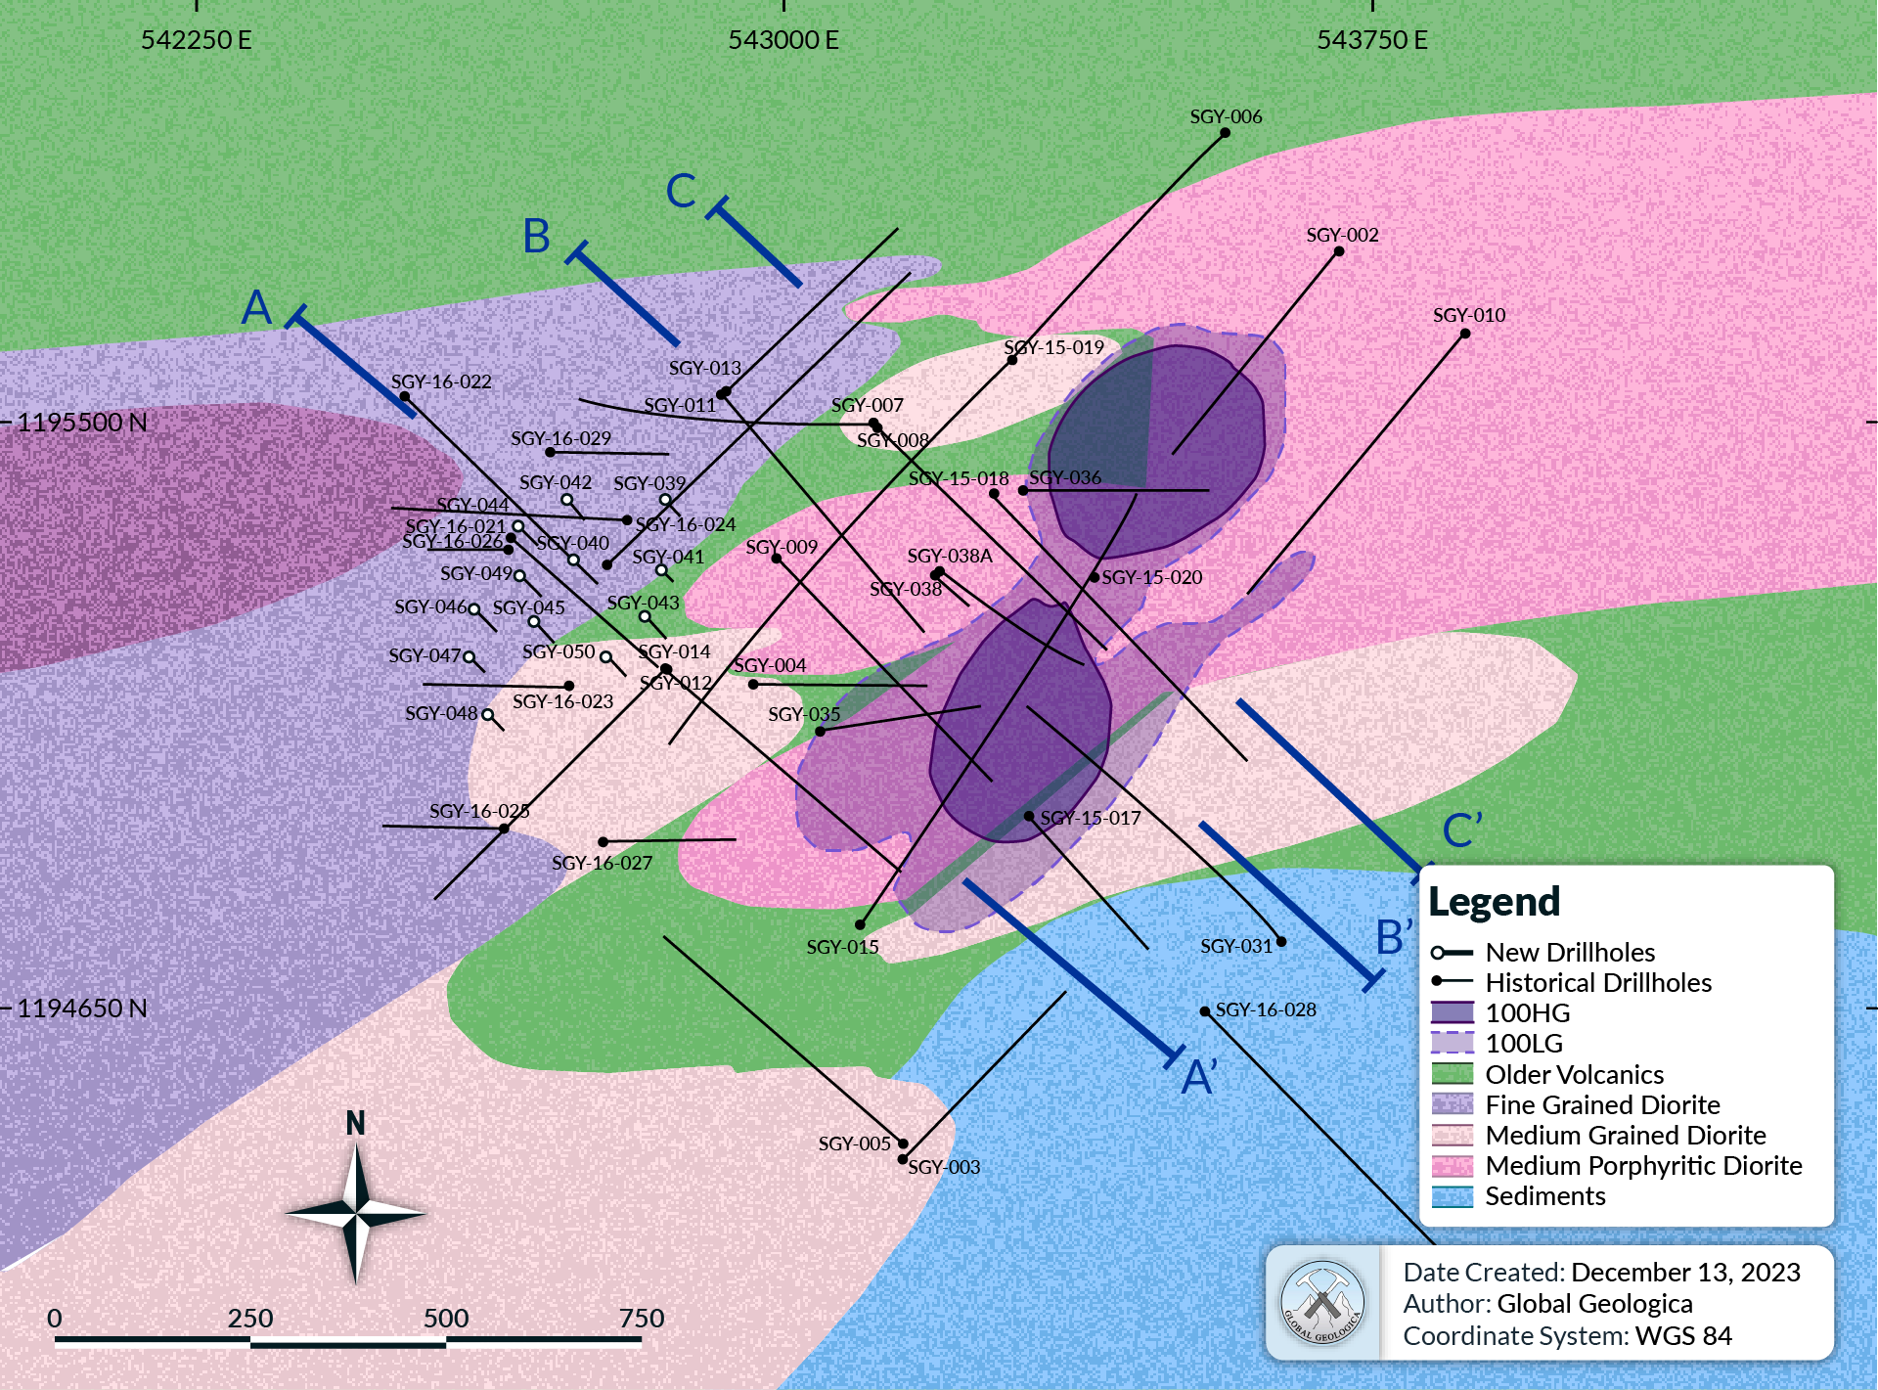

Figure 4. Drill hole locations and interpreted surface geological plan view diagram.

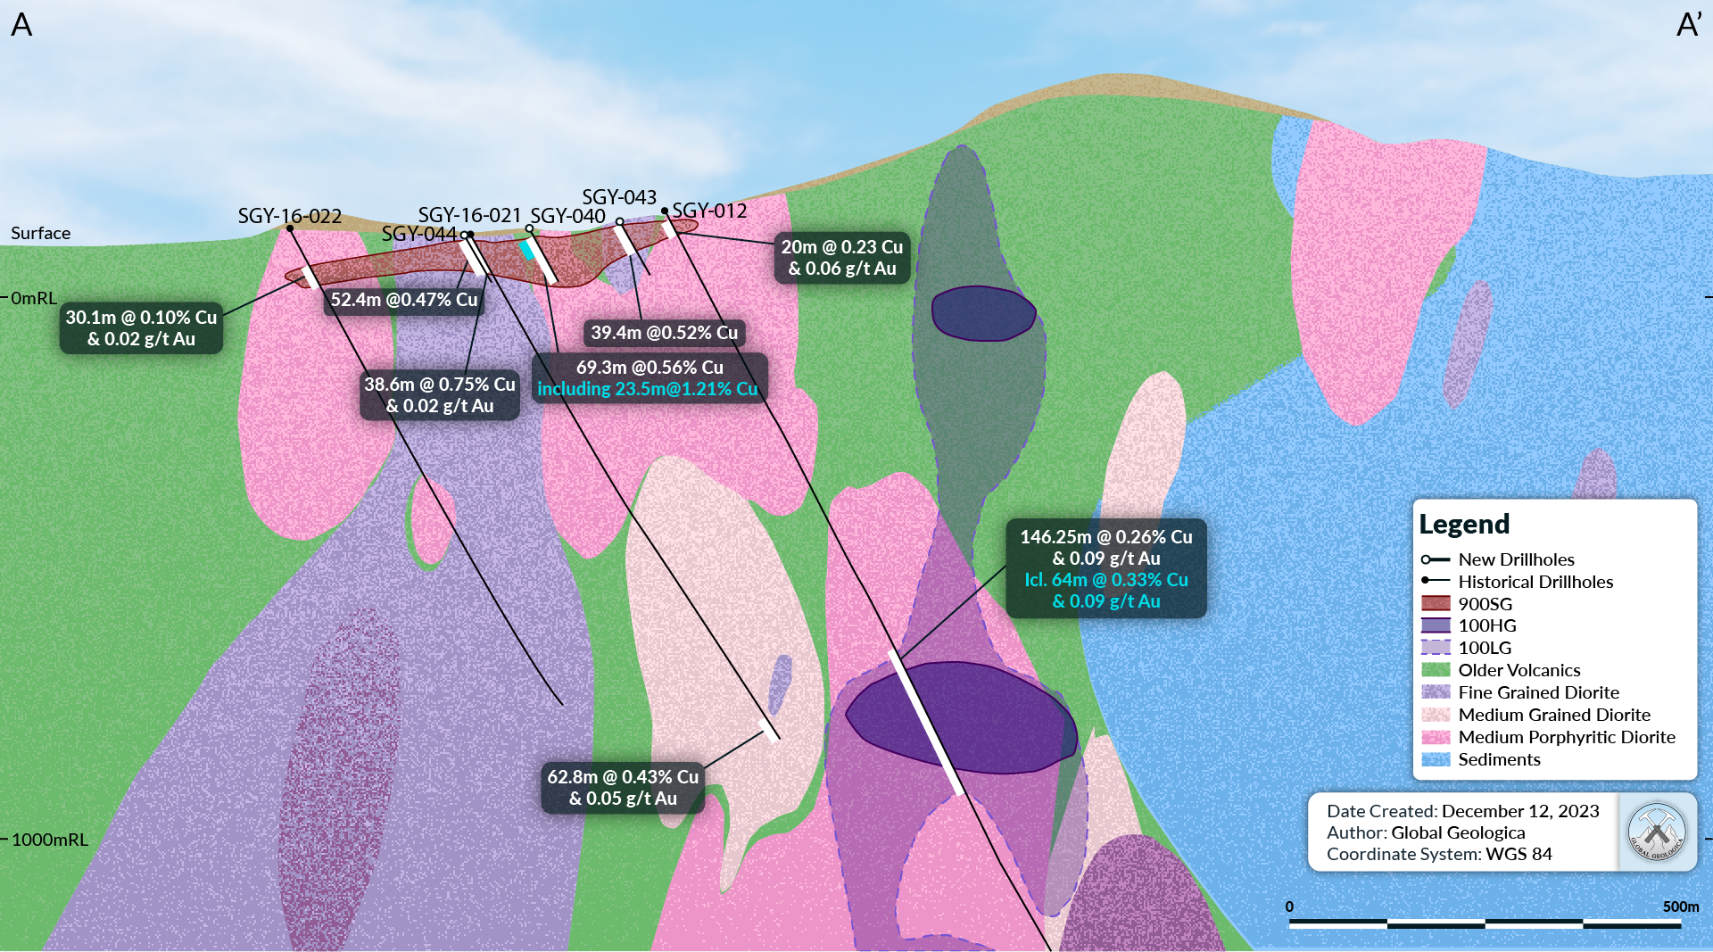
Figure 5. Oblique Cross Section A-A’ , showing the location of mineralised domain 900SG (Supergene mineralisation) and the western section of the 100LG and 100HG mineralised domains.
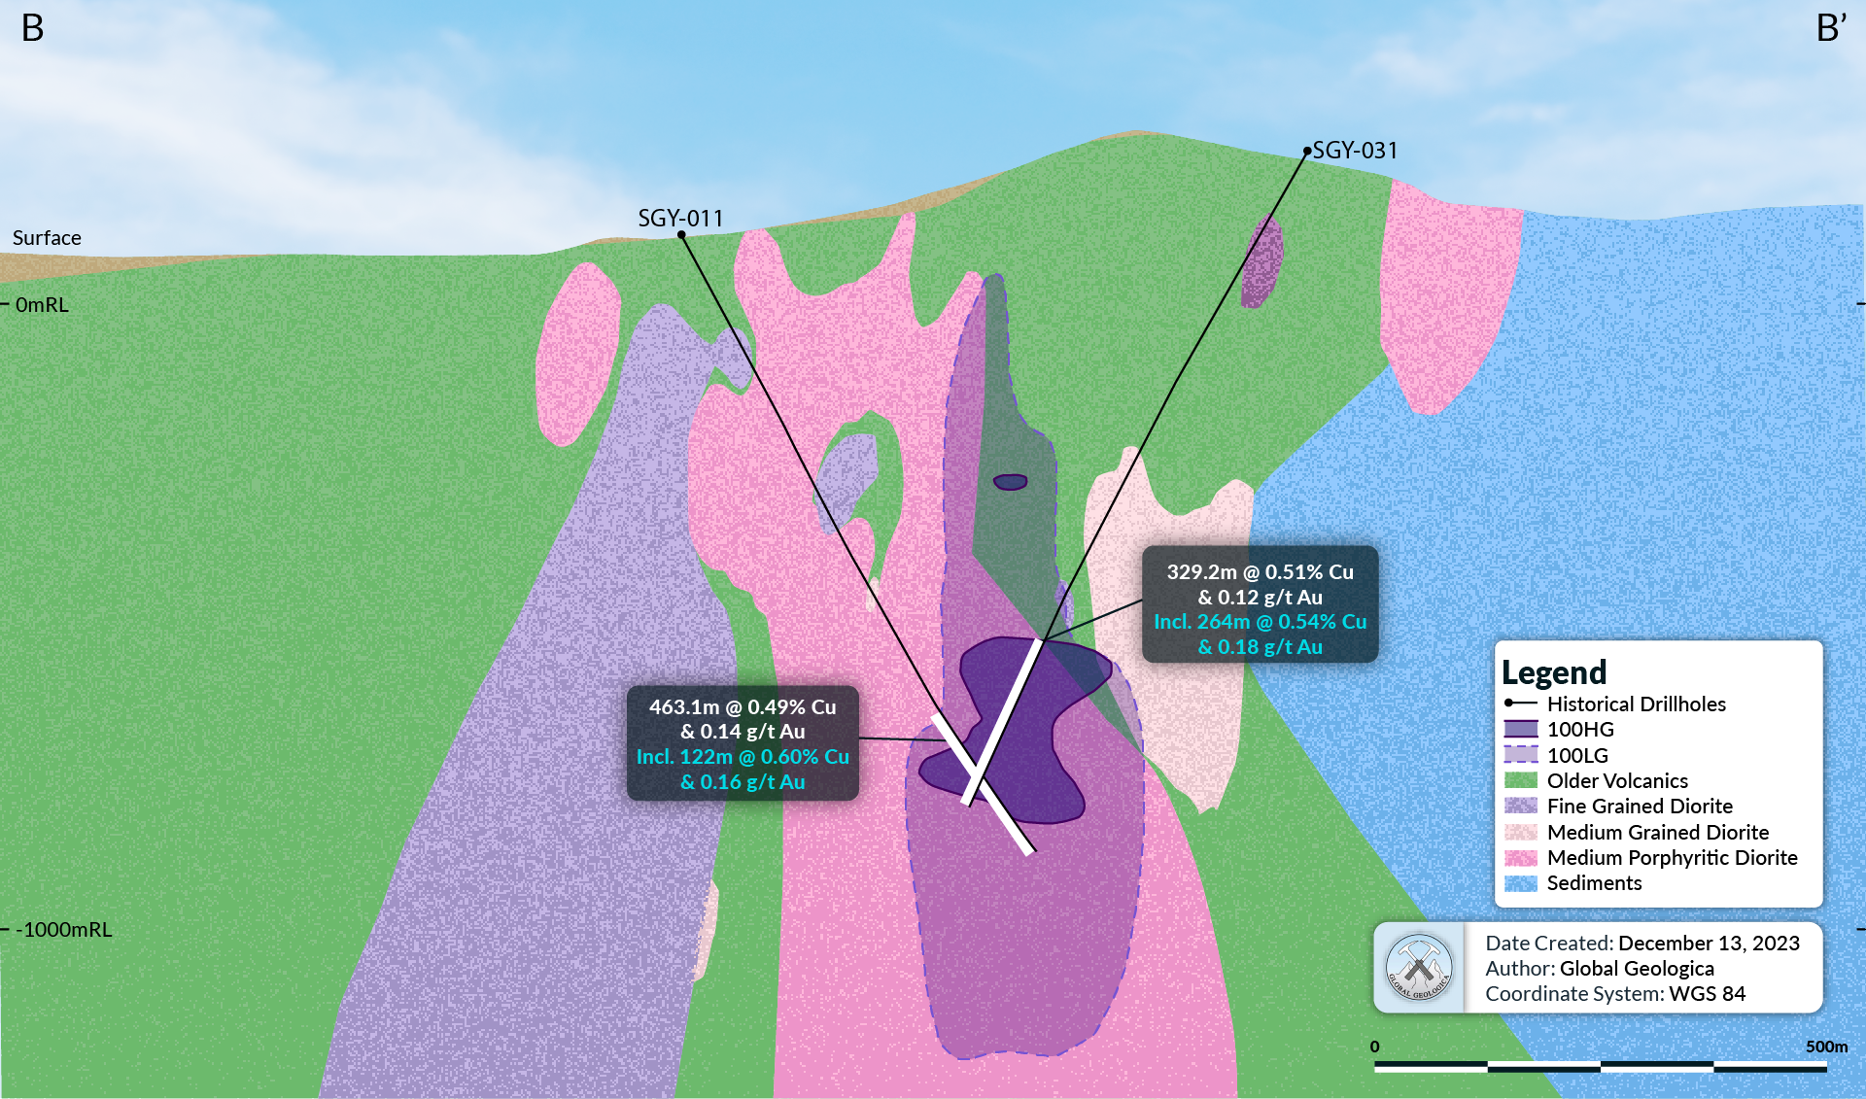

Figure 6. Oblique Cross Section B-B’ showing the location of the 100LG and 100HG mineralised domains.

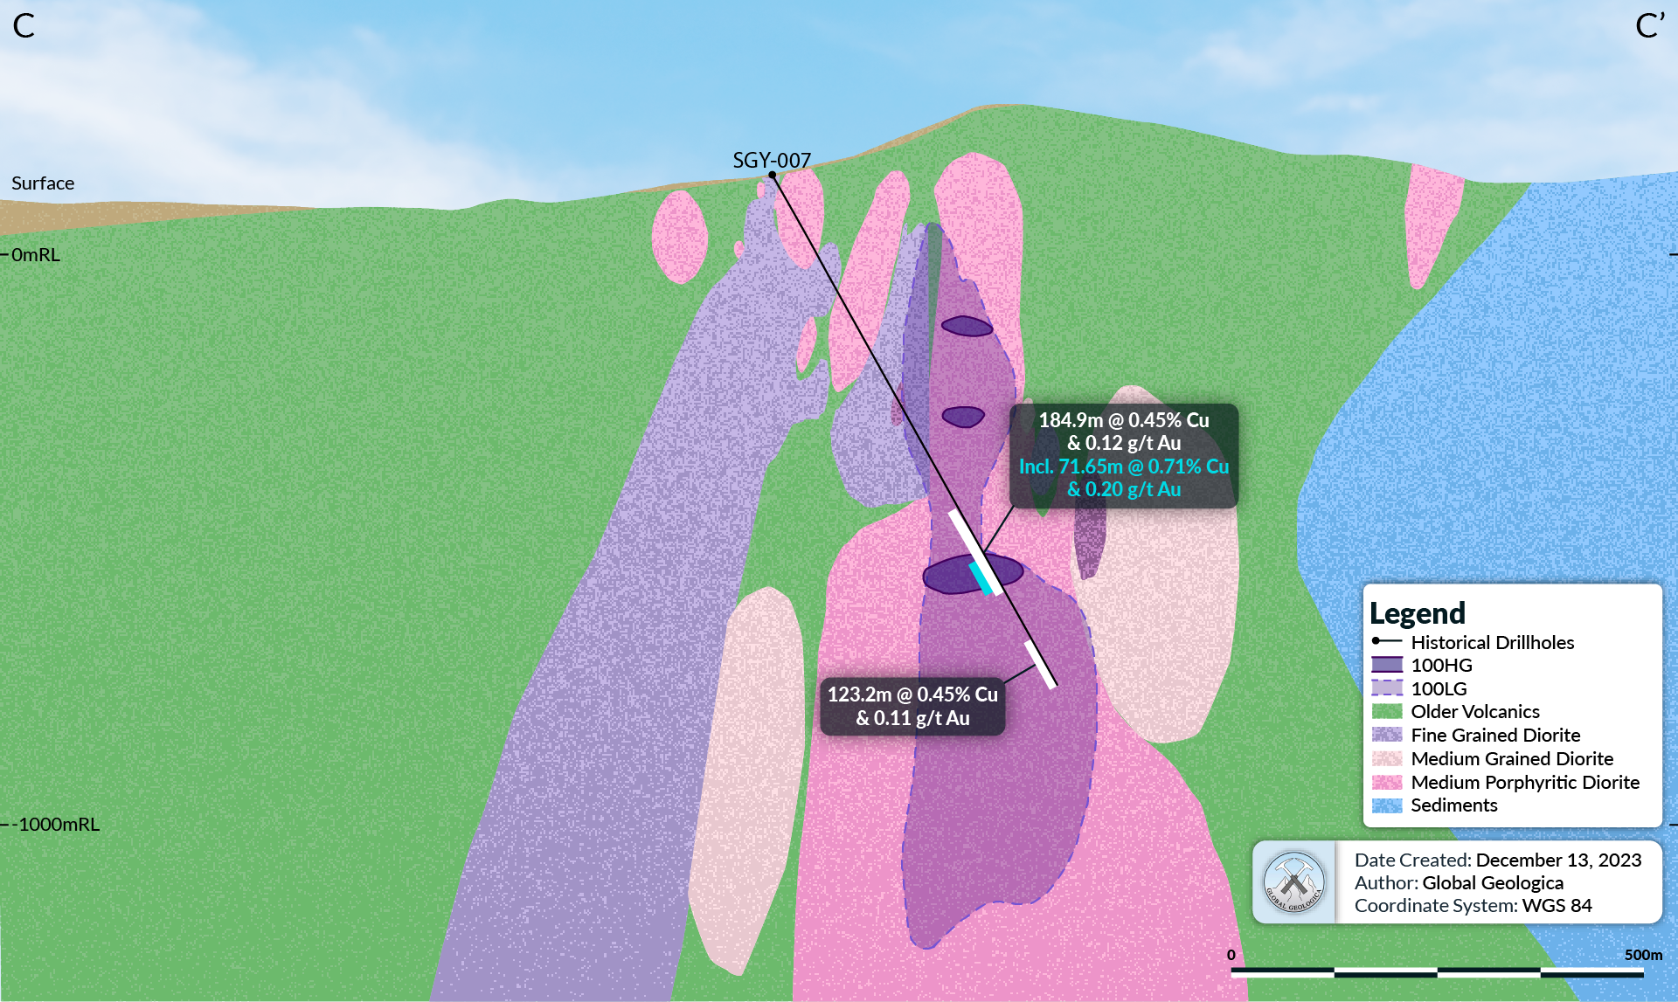
Figure 7. Oblique Cross Section C-C’ showing the location of the 100LG and 100HG mineralised domains.

Geology and Geological Interpretation
Sagay is located at the northernmost tip of the NNE trending volcanic arc related to the eastward subduction beneath the Negros Trench in the southwest offshore of Negros Island. Several porphyry and epithermal mineralisation targets belong in this underexplored mineralisation trend along the eastern side of the island.
The major rocks identified at Purok Tan-ao are a series of intermediate igneous rocks intruding into older host rocks composed of basalts overlain by metamorphosed sedimentary rocks and felsic volcanics. These rocks are in turn overlain by Quaternary pyroclastic rocks that consist of tuff and tuff breccias. The intermediate intrusions include several diorites and andesite porphyry.
Three distinct Diorite intrusives were identified. Following the local nomenclature in Sagay Project, these are (from oldest to youngest) the (1) Equigranular Diorite (MEQ), (2) Medium-grained Porphyritic Diorite (MPOC), and the (3) Fine-grained Equigranular Diorite (FEQ). These intrusive rocks have distinct textures and visible cross cutting relationships. Widespread strong silica - clay and outer chlorite alteration is notable in the deposit. This 8km by 4km alteration zone is indicative of a large magmatic hydrothermal system.
There are multiple types of porphyry mineralisation observed within the Purok Tan-ao Deposit. The dominant type is related to early-stage porphyry quartz stockwork veins with associated potassic alteration and chalcopyrite as the dominant copper sulphide. A later-stage porphyry Cu-Mo type mineralisation has been identified and is hosted in silica – sericite – chlorite alteration. In addition, evidence exists for a later-stage epithermal vein deposit type which exist within close proximity to the large-scale porphyry copper-gold mineralisation.
At this stage, only the porphyry copper-gold type of deposit was defined in the MRE.

Drilling Techniques
All of the drilling data used for the Sagay MRE is based on diamond drilling information from a total of 45 diamond drill holes—with a cumulative meterage of 25,782.1m.
Initial diamond drilling was conducted between December 2012 and 2016 by Freeport-McMoRan, who completed a total of 28 drill holes at Purok Tan-ao, with an aggregate core depth of 22,516.70 metres.
From November 2021 to April 2022, Celsius has completed a total of 4 drill holes and 1 offset, for a total to 2,440 metres. More recently in late 2023, Celsius completed a further 12 shallow drill holes which are the focus for this Mineral Resource update. These shallow drill holes relate to the 900SG mineralised domain with a total meterage of 824.7m.

Sampling and Sub-sampling Techniques
The following sub sampling and sample preparations were followed for all the diamond drilling at Sagay.
Half core samples were collected from diamond holes drilled from the surface. All drill cores were generally sampled at 2m intervals. In cases where geological and mineralogical characteristics change, the sample length is reduced to best fit the geological contact, with a minimum observed sample size of one metre. Sampling typically commenced after the overburden horizon depth was exceeded.
Cut samples were bagged on site prior to delivery to the laboratory (Intertek) in Manila for sample preparation and analysis.

Sample Analysis Method
All samples were analysed at the Intertek, an internationally recognised and ISO/IEC 17025:2005 & ISO/IEC 17020:2004 certified independent laboratory in Manila.
Copper (Cu) values were analysed by means of multi-acid (4-acid) digest. Elements were determined by ICP-OES/MS with AAS finish. Samples were fire assayed for gold (Au) using a 50-gram charge, with a detection limit of 0.005 ppm.

Estimation Methodology
A parent cell block size of 10m x 10m x 10m was chosen based on the general dimensions of the interpreted ore domains, and the likely mining method.
Ordinary Kriging was chosen as the interpolation method for the block model which defines the MRE.
The parameters for Ordinary Kriging were based on an analysis of the variograms for each domain in addition to some broad assumptions with regards to the direction and continuity of the copper and gold mineralisation associated with each defined mineralised domain. The variograms were located along the plane of the interpreted controlling geological trend which is striking at approximately 50 degrees at a near vertical dip.
A broad review of the statistics for each domain did not identify significant high value outliers that are considered likely to result in an overestimated either locally or globally to the grade distribution within the block model. Therefore, no top cut was applied to the MRE.

Classification Criteria
The mineralisation is constrained within boundaries which are also considered to define the limits for each domain as supported by the current drill hole information. Within these domain constraints, minimum search distances and composited drill hole information parameters determined which locations were defined as Measured, Indicated, Inferred or as further Exploration Targets.
A small portion of the 900SG was classified in the Measured category where there is tighter drill spacing (less than 50m), multiple drill holes which show continuity of mineralisation and the variogram analysis is also supporting of the relationship of the assay data between drill holes.
The Indicated category was classified based on maximum distance of 150m to the major position, 85m to the semi-major axis and 25m in the minor direction for the limits, with a minimum number of samples at 8 and maximum number of samples at 16. A minimum of two drill holes was also applied for the Indicated category.
The Inferred Mineral Resource represents over 90% of the total MRE due to the thick and broadly spaced copper intersections as deeper levels which contain the most copper mineralisation identified to date at Purok Tan-ao. This category was extended for twice the distances applied to the Indicated Resource pushing the limits search ellipse to 300m x 150m x 50m, with a minimum of four samples and maximum of 20 samples defined for each block.
No restriction on the number of drill holes was applied for the Inferred Mineral Resource category.

Cut-off Grade
A preferred lower cut-off grade of 0.2% copper has been used in the reported MRE. This is considered appropriate based on the geological continuity associated with copper mineralisation above 0.2% copper in addition to a broad economic cut-off point based on a ~US$10,000/t copper price.

Dimensions
The mineralisation at Purok Tan-ao is classified as a porphyry copper-gold deposit which, at deeper levels (below 400m depth), has a broad geometry of up to 1km along strike towards the north-east (with a main trend of ~45º azimuth) and true widths of up to 280m. At shallower levels, the copper mineralisation is broken up into multiple domains which are individually up to 600m along strike and with true widths of up to 150m.

The 900SG domain is a shallow, flat lying zone of mineralisation which has formed along the current and ancient water table at a broadly horizontal orientation. This domain is elongated in the direction of some interpreted controlling faults and/or source porphyry copper mineralisation. These trends appear to be both north-east and north-west in orientation.

Metallurgical and Mining Parameters
For the 900SG domain which is the basis of the Feasibility Study, utilised a potential surface mine approach with an interpreted costs of US$3.30/t for mining and US$4.8/t for processing.
Possible later mining development costs of US$10/t to US$7/t and processing costs of US$7/t to US$4/t respectively for a medium sized (5Mt to 10Mt per annum) underground block caving mining method and processing using floatation (to produce a copper-gold concentrate) have been assumed where applicable for the MRE.
This cost range estimate matches closely with a broad geological cut-off grade of between 0.15% copper and 0.25% copper (at a forward-looking Copper Price of ~US$10,000/t).

Study Results
Based on the resource model, mining parameters, and metallurgical test works, a Mining Project Feasibility Study was submitted to the Philippine Mines and Geosciences Bureau on 20 December 2023 confirming the presence of minerals in the area which are recoverable by processing the ore through gravity separation which was determined to be economically sound, ensuring environmental protection and preservation methods would be implemented through the advanced mining technologies.

The study focused on the shallow supergene chalcocite deposit which is suitable for a medium-scale surface mining operation. The copper concentrate produced will have no deleterious elements which makes it highly marketable.

Technical, environmental, and social considerations were incorporated in the mine design to reduce the mine footprint to approximately 20 hectares. The process plant is engineered to enhance the ore through a gravity concentration method which is effective in extracting valuable components form the ore, thus contributing to the overall success of the ore beneficiation process.

Metallurgical test works indicated that the tails produced is non-acid generating. All tailings will be managed through dry stacking method which eliminates the need for a tailings dam, thus removing the possibility of environmental impacts (tailings spill). Other alternative disposal methods are currently being studied, including the potential use of tailings for hollow block manufacturing as a community livelihood program, road base, and landfill among others.

Next Steps
Following the submission of the DMPF, the key technical, environmental, and social plans and programs are under review by the Philippine Government. Once approved, the Company will apply for a mineral agreement with the government.

Listing Rule 5.19 and 5.23 Disclosure

The information is this announcement with respect to the MRE for the Sagay Project was first announced by the Company to ASX on 7 November 2022. Where reference is made to previous announcements of exploration results in this announcement, the Company confirms that it is not aware of any new information or data that materially affects the information and results included in the original market announcements and that all material assumptions and technical parameters underpinning the MRE continue to apply and have not materially changed.

Forward Looking Statements

Some of the statements appearing in this announcement may be in the nature of forward-looking statements. You should be aware that such statements are only predictions and are subject to inherent risks and uncertainties. Those risks and uncertainties include factors and risks specific to the industries in which the Company operates and proposes to operate as well as general economic conditions, prevailing exchange rates and interest rates and conditions in the financial markets, among other things. Actual events or results may differ materially from the events or results expressed or implied in any forward-looking statement.

No forward-looking statement is a guarantee or representation as to future performance or any other future matters, which will be influenced by a number of factors and subject to various uncertainties and contingencies, many of which will be outside the Company’s control.

The Company does not undertake any obligation to update publicly or release any revisions to these forward-looking statements to reflect events or circumstances after today's date or to reflect the occurrence of unanticipated events. No representation or warranty, express or implied, is made as to the fairness, accuracy, completeness or correctness of the information, opinions or conclusions contained in this announcement. To the maximum extent permitted by law, none of the Company’s Directors, employees, advisors, or agents, nor any other person, accepts any liability for any loss arising from the use of the information contained in this announcement. You are cautioned not to place undue reliance on any forward-looking statement. The forward-looking statements in this announcement reflect views held only as at

Competent Persons Statement

Information in this report relating to the reporting of Mineral Resource Estimates and Exploration Results is based on information compiled, reviewed and assessed by Mr. Steven Olsen, who is a Member of the Australasian Institute of Mining and Metallurgy and the Australian Institute of Geoscientists. Mr. Olsen is an Employee of Global Geologica, an independent consulting Company to Celsius Resources Limited, and has sufficient experience which is relevant to the style of mineralisation and type of deposit under consideration and to the activity which he is undertaking to qualify as a Competent Person as defined by the 2012 Edition of the Australasian Code for reporting of Exploration Results, Mineral Resources and Ore Reserves. Mr. Olsen consents to the inclusion of the data in the form and context in which it appears.

This announcement has been authorised by the Board of Directors of Celsius Resources Limited.

The information contained within this announcement is deemed by the Company to constitute inside information as stipulated under the Market Abuse Regulations (EU) No. 596/2014 as it forms part of UK Domestic Law by virtue of the European Union (Withdrawal) Act 2018.

Celsius Resources Contact Information
Level 5, 191 St. Georges Terrace
Perth WA 6000

PO Box 7059
Cloisters Square PO
Perth WA 6850

P: +61 2 8072 1400
E: info@celsiusresources.com.au
W: www.celsiusresources.com

Celsius Resources Limited
Peter Hume  (Managing Director) | P: +61 2 8072 1400  E: info@celsiusresources.com.au  W: www.celsiusresources.com
Multiplier Media  Jon Cuthbert | M: +61 402 075 707  E: jon.cuthbert@multiplier

Beaumont Cornish Limited  (Nominated Adviser)  Roland Cornish/Felicity Geidt/Andrew Price | P: +44 (0) 207 628 3396  E: corpfin@b-cornish.com.uk
WH Ireland (Broker)  Harry Ansell/James Joyce/Isaac Hooper | P: +44 (0) 20 7220 1666

Appendix 1: The following tables are provided to ensure compliance with the JORC Code (2012) requirements for the reporting of Exploration Results for the MCB Project.

SECTION 1:

Sampling Techniques and Data
(Criteria in this section apply to all succeeding sections.)
Criteria | JORC Code explanation | Commentary
Sampling techniques | Nature and quality of sampling (e.g., cut channels, random chips, or specific specialised industry standard measurement tools appropriate to the minerals under investigation, such as down whole gamma sondes, or handheld XRF instruments, etc). These examples should not be taken as limiting the broad meaning of sampling.  Include reference to measures taken to ensure sample representivity and the appropriate calibration of any measurement tools or systems used.  Aspects of the determination of mineralisation that are Material to the Public Report. In cases where ‘industry standard’ work has been done this would be relatively simple (e.g., ‘reverse circulation drilling was used to obtain 1 m samples from which 3 kg was pulverised to produce a 30 g charge for fire assay’). In other cases, more explanation may be required, such as where there is coarse gold that has inherent sampling problems. | Samples were collected from diamond core drilled from the surface. All drill core was generally sampled on 2-meter intervals. In cases where geological and mineralogical characteristics change, sample length was not less than 1 meter.  Core samples cut into half using diamond core saw following the cutting lines marked by the Geologist. Split cores returned to its respective core tray.  Samples were shipped by company vehicle to Intertek Testing Services which is an external laboratory located in Manila, Philippines.  Crushed samples were fire assayed for gold (Au) using a 30-gram charge, with a detection limit of 0.005 ppm. Gold values greater than 50 ppm were determined by gravimetric fire assay.  Copper (Cu) values were assayed using four-acid digestion. Elements determined by ICP-OES/MS with AAS finish with final reporting for a total of 36 elements.
Drilling techniques | Drill type (e.g., core, reverse circulation, open-hole hammer, rotary air blast, auger, Bangka, sonic, etc) and details (e.g. core diameter, triple or standard tube, depth of diamond tails, face-sampling bit or other type, whether core is oriented and if so, by what method, etc). | Previous exploration and drilling were conducted between December 2012 and 2016 by Freeport-McMoRan, completing a total of 28 drill holes for the Purok Tan-ao deposit, with an aggregate depth of 22,516.70 meters.  A further exploration program had commenced between November 2021 to April 2022, completing a total of 4 drill holes and 1 offset hole in the prospect, with a cumulative depth of 2,440.70 meters.  The most recent drilling program was completed in late 2023 with 12 shallow diamond drill holes for a total length of 824.7m  There are a total of 45 holes in the database used for the MRE which is the subject of this release for a cumulative depth of 25,782.1 meters.  The core drilling utilised a triple-tube core barrel from collar to end-of-hole to ensure optimum core recovery, with the deepest hole drilled being 1,400 meters.
Drill sample recovery | Method of recording and assessing core and chip sample recoveries and results assessed.  Measures taken to maximise sample recovery and ensure representative nature of the samples.  Whether a relationship exists between sample recovery and grade and whether sample bias may have occurred due to preferential loss/gain of fine/coarse material. | Core recovery has been recorded for every interval as part of the routine geomechanical logging.  Recovered core lengths on average were measured to be over 97% for the drill holes with form part of the MRE, indicating a high recovery and minimal lost core.  All drilling activities were supervised by company Geologists. Trained Core house technician were responsible for the core recovery determination.
Logging | Whether core and chip samples have been geologically and geotechnically logged to a level of detail to support appropriate Mineral Resource estimation, mining studies and metallurgical studies.  Whether logging is qualitative or quantitative in nature. Core (or costean, channel, etc) photography.  The total length and percentage of the relevant intersections logged. | Geologists were tasked to oversee the daily quick log report down to sampling. Daily quick log form was completed to identify the geological details such as lithology, alteration and mineralisation with corresponding percentage estimate of Cu minerals and Cu grade, using an established geological code.  Detailed logging proceeds describing geological characteristics present in the core, i.e. lithology, alteration, mineralogy, structures, etc.  Core photography was undertaken after completing the geomechanical logging.
Sub-sampling techniques and sample preparation | If core, whether cut or sawn and whether quarter, half or all core taken.  If non-core, whether riffled, tube sampled, rotary split, etc and whether sampled wet or dry.  For all sample types, the nature, quality and appropriateness of the sample preparation technique.  Quality control procedures adopted for all sub-sampling stages to maximise representivity of samples.  Measures taken to ensure that the sampling is representative of the in-situ material collected, including for instance results for field duplicate/second-half sampling.  Whether sample sizes are appropriate to the grain size of the material being sampled. | Samples were routinely taken over a 2m interval, and cut in half, with half of the drill core sent for analysis and half of the drill core retained for future reference.  Samples were cut on site using a hand core saw. Samples were then selected and bagged on site prior to delivery to the laboratory (Intertek) in Manila for sample preparation.  The sample size is considered appropriate for type of material being samples.
Quality of assay data and laboratory tests | The nature, quality and appropriateness of the assaying and laboratory procedures used and whether the technique is considered partial or total.  For geophysical tools, spectrometers, handheld XRF instruments, etc, the parameters used in determining the analysis including instrument make and model, reading times, calibrations factors applied and their derivation, etc.  Nature of quality control procedures adopted (e.g. standards, blanks, duplicates, external laboratory checks) and whether acceptable levels of accuracy (i.e. lack of bias) and precision have been established. | Samples were fire assayed for gold (Au) using a 30-gram charge, with a detection limit of 0.005 ppm. Gold values greater than 50 ppm were determined by gravimetric fire assay. Copper (Cu) values were assayed using four acid digestion. Elements determined by AAS finish.  The procedures for the submission of samples to the laboratory also include the regular insertion of QA/QC samples in every transmittal form or batch, which was typically delivered to the laboratory in batches of 50 numbered samples. For each batch of 50 samples a total of 43 came from core samples and an additional 7 samples were included for QA/QC checks, which were as follows:  - Four referenced standards  - One referenced Blank  - One coarse (unrecognisable) blank  - One field duplicate taken from the quartered core  After sample preparation, all samples were sent for final analysis to Intertek at their laboratory in Manila. Intertek is an internationally recognised and ISO/IEC 17025:2005 & ISO/IEC 17020:2004 certified independent laboratory.
Verification of sampling and assaying | The verification of significant intersections by either independent or alternative company personnel.  The use of twinned holes.  Documentation of primary data, data entry procedures, data verification, data storage (physical and electronic) protocols.  Discuss any adjustment to assay data. | Analytical procedures provided by an internationally certified laboratory is considered in line with industry standard for the type of deposit and mineralisation identified at the Property.  Apart from the verification of the procedures and results as described above, no further verification of the sampling and assaying have been undertaken.  None of the diamond drill holes in this report are twinned.
Location of data points | Accuracy and quality of surveys used to locate drill holes (collar and down-hole surveys), trenches, mine workings and other locations used in Mineral Resource estimation.  Specification of the grid system used.  Quality and adequacy of topographic control. | All data reference points and maps for the Sagay database, including drill hole collar co-ordinates are recorded in WGS 84/UTM Zone 51N.  Compass measurements taken by Geologists were used to establish the dip and azimuth of the collar hole as part of their initial collar surveys. Drill collar locations were positioned using a handheld Garmin GPS unit, set to UTM WGS 84 Zone 51N coordinate reference system, with an accuracy expected to be within 2 metres. Downhole surveys were also completed using a Keeper Gyro at 50m intervals.  Collar surveys were then logged into the master MS Excel spreadsheet as part of the database.
Data spacing and distribution | Data spacing for reporting of Exploration Results.  Whether the data spacing, and distribution is sufficient to establish the degree of geological and grade continuity appropriate for the Mineral Resource and Ore Reserve estimation procedure(s) and classifications applied.  Whether sample compositing has been applied. | In the MRE, drill hole assays were composited to 2 metres which matches closely with the sample length down hole for all drill hole sampling completed at Sagay.  The drilling completed at Sagay is dominantly towards the north-west or south-east which is perpendicular to the main trend of the copper mineralisation and host rock geology. The drill spacing for the drill holes in this orientation is irregular, ranging from just over 150m separation up to 400m separation.  Drill hole spacing for the 900SG area have been reduced to between 50m and 100m with the results from the 2023 drilling program.  Some drilling has been conducted towards the south-west which is sub-parallel to the main trends of copper mineralisation. These drill holes have not had a significant influence on the MRE due to their poor orientation for both the copper boundary definition and for sampling.  The drill hole spacing has broadly defined the major trends to the copper-gold mineralisation.
Orientation of data in relation to geological structure | Whether the orientation of sampling achieves unbiased sampling of possible structures and the extent to which this is known, considering the deposit type.  If the relationship between the drilling orientation and the orientation of key mineralised structures is considered to have introduced a sampling bias, this should be assessed and reported if material. | The drill hole orientations at Purok Tan-ao are largely towards the south-west or towards the south-east. These orientations were chosen to cut roughly perpendicular to the interpreted dominant structural trend and possible trend of the mineralised intrusive rocks which are trending towards the north-east, and some evidence of a trend to the north-west.  The dominant trend of the intrusive rocks which are interpreted to be related to the copper-gold mineralisation has an overall strike of 40 to 60 degrees and a near to vertical dip. The drill holes which are dipping approximately 60 degrees towards the south-east appear to be at a good angle to effectively test the copper-gold mineralisation in this trend. The holes which have been drilled towards the south-east are optimal for some cross cutting north-west trending structures, but at a poor angle to test the dominant copper-gold mineralisation which is sub parallel to these drill holes.  The 900SG domain is at a horizontal orientation and drilling has largely been completed at a 60-degree angle which is appropriate for defining both this flat lying domain in addition to potential vertical feeder structures related to the primary porphyry copper source of this supergene copper domain.
Sample security | The measures taken to ensure sample security. | - The following standard procedures were documented to have been followed in relation to sample security for all Purok Tan-ao diamond drilling:  Sample bags are arranged in sequence according to its sample number. These are then weighed and jotted down to a sample dispatch note which details the sample numbers, sample type and laboratory processing required. Geologists ensures that the transmittal form is correct for encoding and submission. The samples are checked by a Mines and Geological Sciences (MGB) Geologist before issuance of an Ore Transport Permit (OTP). Upon receipt of the OTP, the sample bags are sealed in a crate, and sent to Manila via a certified courier contractor. Upon arrival in Manila, a company vehicle checks the samples before they’re delivered to Intertek Testing Services. No unsupervised third parties were given access prior to the chain of custody procedure.  - Upon receipt of samples, these were arranged in sequence to review the numbers, and a sample received report was sent to the Geologists. Samples are individually weighed again for verification.  Samples were delivered to Intertek Testing Services along with two copies of the sample dispatch form. One copy for the laboratory to accept custody of the sample, and the signed/received copy return to database custodian given access prior to the chain of custody procedure.
Audits or reviews | The results of any audits or reviews of sampling techniques and data. | - No other specific audit or review was conducted other than the validation checks by the author documented earlier regarding the sample preparation, analysis or security for the information for the Sagay drill hole database.

SECTION 2:

Reporting of Exploration Results
(Criteria listed in the preceding section also apply to this section.)
Criteria | JORC Code explanation | Commentary
Mineral tenement and land tenure status | Type, reference name/number, location and ownership including agreements or material issues with third parties such as joint ventures, partnerships, overriding royalties, native title interests, historical sites, wilderness or national park and environmental settings.  The security of the tenure held at the time of reporting along with any known impediments to obtaining a licence to operate in the area. | The Sagay Copper project is at the north-eastern part of Negros Island within the Cities of Sagay and Escalante Negros Occidental.  The underlying title is in the name of the Philippines registered corporation Tambuli Mining Company Inc. (TMCI) is currently 100% owned by a private Delaware Company who in turn is owned by Celsius Resources Ltd.  Tambuli Mining Company, Inc. (TMCI) was first granted a single Exploration Permit denominated as EP-000003VI on 6 May 2008 under Phelps Dodge Exploration Corporation – Philippine Branch (PDEC), which was later acquired by Freeport-McMoRan Exploration Corporation – Philippine Branch (FMEC) in 2007. The permit area covers a total of 4,594.23 hectares, which has recently been reduced to 1,791.3736 hectares where the Deposit is situated.  On August 11, 2021, TMCI, now a subsidiary of CLA, was granted a fourth exploration permit renewal (extension) which is valid until February 10, 2024. The current two-year renewal period allowed the resumption of ore definition drilling activities aimed to define the deep ore zone (two drill holes), its shallow/near surface extensions (three drill holes), and test possible near surface chalcocite ore zones (three drill holes).  TMCI has recently submitted an application for a Declaration of Mining Project Feasibility (DMPF), which is the first step towards a further application of a mining permit which will allow for the further exploration and development of the Sagay Project once granted.
Exploration done by other parties | Acknowledgment and appraisal of exploration by other parties. | Exploration work and drilling was completed by Tambuli Mining Company Inc. which was a subsidiary of Freeport-McMoRan Exploration Corporation-Philippine Branch from year 2008 to 2016.  The exploration activities were generally completed over two stages. From 2008 up to 2009, the work was focused on project assessment which included surface sampling and mapping, in addition to a number of ground geophysical surveys, most particularly a ground magnetic survey and a series of 2D Induced Polarisation surveys.  From 2012 through to 2016 the exploration activities were focused on diamond drilling to test the targets identified from the work completed over 2008 and 2009.  A further exploration under Celsius Resources commenced between November 2021 to April 2022, completing a total of 4 drill holes and 1 offset hole in the prospect, with a cumulative depth of 2,440.70 meters.  The most recent drilling program was completed in late 2023 with 12 shallow diamond drill holes for a total length of 824.7m  The drilling activities were predominately at the Purok Tan-ao with all drilling results reported in this release.
Geology | Deposit type, geological setting and style of mineralisation. | The geological setting for the Purok Tan-ao copper-gold mineralisation is typical of a porphyry copper + gold + moly deposit as commonly defined in many academic papers (Hedenquist and Lowernstern, 1994; Sillitoe, R. H., 2010. Corbett and Leach, 1997). The mineralisation and associated alteration exist predominantly within a series of large intrusive bodies that have intruded the host country rocks.  The Sagay Project host rocks are part of the Negros Occidental Island, which is situated in western Visayas, Central Philippines. The eastern part of the island comprises a NNE trending volcanic arc related to the eastward subduction beneath the Negros Trench in the southwest off-shore of Negros Island.  The major rocks identified are a series of intrusions which exist within an older host rock setting of basalt rocks that are overlain by felsic tuffs and metamorphosed sedimentary rocks. These rocks are in turn overlain by Quaternary pyroclastic rocks that consist of tuff and tuff breccias. Intrusions include diorite and andesite porphyry. Post-mineral Pliocene to Pleistocene andesitic to dacitic volcanics cover the northern part of the area.  Three distinct diorite intrusives were identified, following the local nomenclature in the Project, these are (from oldest to youngest) the: (1) Equigranular Diorite (MEQ), (2) Medium-grained Porphyritic Diorite (MPOC), and the (3) Fine-grained Equigranular Diorite (FEQ). These intrusive rocks have distinct textures and visible cross cutting relationships.  Widespread strong silica clay and outer chlorite alteration is notable in the deposit. This 8km by 4km alteration zone is indicative of a large magmatic hydrothermal system. the surface alteration is approximately 1.7km by 1.7km, which tends to extend southwest along possible controlling structures.  The following are the established ore types in the deposit:  - Ore Type 1 – Early porphyry to late porphyry mineralisation  - Ore Type 2 – Mixed zone of late porphyry mineralisation and epithermal mineralisation.  Ore Type 3 – possible mixed zone of supergene enrichment and high sulfidation to intermediate sulfidation epithermal mineralisation. Divided into OT3A and OT3B based on the associated mineral assemblages.
Drill hole Information | A summary of all information material to the understanding of the exploration results including a tabulation of the following information for all Material drill holes:  easting and northing of the drill hole collar  elevation or RL (Reduced Level – elevation above sea level in metres) of the drill hole collar  dip and azimuth of the hole  down hole length and interception depth  hole length.  If the exclusion of this information is justified on the basis that the information is not Material and this exclusion does not detract from the understanding of the report, the Competent Person should clearly explain why this is the case. | In summary, the drill hole in the database for the Property which relate specifically to the Purok Tan-ao area consists of 45 diamond core drilled holes with an accumulative meterage of 25,782.1m after the inclusion of the drill holes which are the subject of this release.  No drill hole information has been excluded.
Data aggregation methods | In reporting Exploration Results, weighting averaging techniques, maximum and/or minimum grade truncations (eg cutting of high grades) and cut-off grades are usually Material and should be stated.  Where aggregate intercepts incorporate short lengths of high-grade results and longer lengths of low-grade results, the procedure used for such aggregation should be stated and some typical examples of such aggregations should be shown in detail.  The assumptions used for any reporting of metal equivalent values should be clearly stated. | Significant intersections for the purpose of representing the defined mineralisation in the MRE which is the subject of this report are shown in figures 5 to 7. The intersections reported are aggregated relative to broad mineralised interval which correspond with a definable and continuous zone of copper-gold mineralisation, nominally above a grade of 0.2% copper. The intervals have been reported as weighted average totals. Internal to the broader mineralisation that has been reported, there are some internal higher-grade copper-gold assay results reported (nominally above 0.5% copper) which are interpreted to exist as a continuous domain of higher-grade copper-gold mineralisation. These sections have also been reported as weighted average totals.  Only individual weighted average assay results have been reported and no metal equivalent values have been reported.
Relationship between mineralisation widths and intercept lengths | These relationships are particularly important in the reporting of Exploration Results.  If the geometry of the mineralisation with respect to the drill hole angle is known, its nature should be reported.  If it is not known and only the down hole lengths are reported, there should be a clear statement to this effect (e.g. ‘down hole length, true width not known’). | There are a number of drilling orientations, but generally drill holes were designed on lines oriented towards 130 degrees to the south-east or towards 220 degrees to the south-west and spacing at just over 200m between holes. Where the mineralisation is interpreted to strike roughly perpendicular to the orientation of the drill holes, the angle between the drill hole (typically at a 60-degree dip) and the vertical mineralisation implies true width ranges of between 70-90% of the downhole width.
Diagrams | Appropriate maps and sections (with scales) and tabulations of intercepts should be included for any significant discovery being reported These should include, but not be limited to a plan view of drill hole collar locations and appropriate sectional views. | See figures 3 to 7 for a representative plan and cross sections of the Geology and its relationship to the copper-gold mineralisation at Purok Tan-ao.
Balanced reporting | Where comprehensive reporting of all Exploration Results is not practicable, representative reporting of both low and high grades and/or widths should be practiced to avoid misleading reporting of Exploration Results. | All data for the project has been collected, validated and reported and is considered to be a fair representation of the MRE from the Sagay Project which is the subject of this release.
Other substantive exploration data | Other exploration data, if meaningful and material, should be reported including (but not limited to): geological observations; geophysical survey results; geochemical survey results; bulk samples – size and method of treatment; metallurgical test results; bulk density, groundwater, geotechnical and rock characteristics; potential deleterious or contaminating substances. | Historical exploration since the date of the original grant of EXP000003VI in 2008 was undertaken under the ownership and management of Tambuli Mining Company Inc.  On June 2008, first stage of geological work was established by geological mapping, gridlines preparations, soil and rock sampling, as well as geophysical surveys that consisted of induced polarisation, resistivity and ground magnetic. These activities were completed by 20th of December on the same year.  This was followed by a period of diamond drilling from 2012 through to 2016 for a total of 31 diamond drill holes, 28 of which were drilled at Purok Tan-ao.  Further diamond drilling commenced between November 2021 to April 2022, completing a total of 4 drill holes and 1 offset hole in the prospect, with a cumulative depth of 2,440.70 meters.  The most recent drilling program was completed in late 2023 with 12 shallow diamond drill holes for a total length of 824.7m
Further work | The nature and scale of planned further work (eg tests for lateral extensions or depth extensions or large-scale step-out drilling).  Diagrams clearly highlighting the areas of possible extensions, including the main geological interpretations and future drilling areas, provided this information is not commercially sensitive. | There are a few locations where the potential extensions to the current defined large-scale copper-gold mineralisation could be tested. These locations are largely based on an interpreted north-east strike and near vertical dip to the copper-gold mineralisation.  The location for the possible shallow higher-grade copper-gold at Purok Tan-ao is also yet to be defined. Further drilling along possible north-east or northwest orientations to the previous shallow copper-gold intersections is warranted to test the extent of this mineralisation.  Apart from the direct extensions to the currently defined copper-gold mineralisation, there is considerable scope for further discoveries of two defined deposit types within the Sagay Tenement as follows:  Porphyry copper-gold deposit types  - There are extensive intrusions in the area that are directly related to the copper-gold mineralisation, and which could at multiple locations formed significant high-grade copper-gold deposits.  - Existing geophysical datasets have already identified a number of large untested features that are worthy of drill testing for the potential to discover further large-scale copper-gold mineralisation  Epithermal vein hosted deposit types  It is considered likely that there could be a combination of narrow high grade, and/or more broad large scale and lower grade epithermal deposit types at Purok Tan-ao. There are a number of apparent large-scale structures which exist adjacent to Tan-ao which are worthy of follow up drill testing for this style of deposit. There may be some merit in further surface sampling with a greater emphasis on epithermal gold deposit types. However, the relatively extensive geophysical surveys are already indicating a number or drill ready target positions that are worthy of follow up.

Section 3

Estimation and Reporting of Mineral Resources
(Criteria listed in section 1, and where relevant in section 2, also apply to this section.)
Criteria | JORC Code explanation | Commentary
Database integrity | - Measures taken to ensure that data has not been corrupted by, for example, transcription or keying errors, between its initial collection and its use for Mineral Resource estimation purposes.  Data validation procedures used. | The original assay sheets and drill logs were checked against the drill hole database by the author and no systematic or random errors were identified as part of this validation check of the database.  In addition, the original laboratory reports were checked against the drill hole database. This data review did not identify any systematic or isolated errors in the drill hole database.  Drill core observations and validation steps were completed in September 2022 which included a review of all the defined Ore Domains and broad contact positions between the high grade and low-grade domains in addition to the low-grade ore to waste domain boundaries.  All drill core from the Purok Tan-ao drilling which were used to define the 2024 MRE have been preserved and were available for the author to visually check against the drill logs and recorded assay results.  Geological observations that are recorded in the drill logs leading to the definition of the ore domains at Purok Tan-ao appear consistent and reflective of what could be observed from the drill core by the Author. In addition, copper sulphides and recently weathered copper-sulphides (due to exposure of the drill core at the surface) are observable in the drill core where high-grade copper mineralisation has been reported. The relative presence of copper sulphides and oxidised copper minerals appear reasonably reflective of the assay results reported in the database based on the observations made by the author of the drill core.
Site visits | - Comment on any site visits undertaken by the Competent Person and the outcome of those visits.  - If no site visits have been undertaken indicate why this is the case. | The Author has completed site inspections of the property including detailed review of the drill core which relate to the Mineral Resource Estimate. The field inspections included validation for approximately 30% of the drill collar locations for the drill holes which are included in the Mineral Resource estimate using a handheld GPS.  The review of drill core and field inspections were conducted from September 28 to September 30, 2021.
Geological interpretation | - Confidence in (or conversely, the uncertainty of) the geological interpretation of the mineral deposit.  - Nature of the data used and of any assumptions made.  - The effect, if any, of alternative interpretations on Mineral Resource estimation.  - The use of geology in guiding and controlling Mineral Resource estimation.  - The factors affecting continuity both of grade and geology. | The geological interpretation associated with the Purok Tan-ao Mineral Resource estimate is considered by the author to have a high level of confidence, with limited variability considered likely due to a difference in the geological interpretation.  The interpretation and Mineral Resource estimate have been compared directly with previous interpretations made by the geological staff at Freeport-McMoRan, which completed early stage previous exploration activities at Purok Tan-ao. The copper and gold mineralisation defined in the Mineral Resource estimate has a high level of consistency relative to the geological interpretation completed by Freeport-McMoRan.  The geological controls on the copper-gold mineralisation at the Purok Tan-ao copper-gold mineralisation is typical of a porphyry copper + gold + moly deposit as commonly defined in many academic papers (Hedenquist and Lowernstern, 1994; Sillitoe, R. H., 2010. Corbett and Leach, 1997).
Dimensions | - The extent and variability of the Mineral Resource expressed as length (along strike or otherwise), plan width, and depth below surface to the upper and lower limits of the Mineral Resource. | The copper-gold mineralisation at Purok Tan-ao classified as a porphyry copper-gold deposit at deeper levels (below 400m depth) has a broad geometry of up to 1km along strike towards the north-east (main trend ~45°) and true widths of up to 280m. At shallower levels the copper mineralisation is broken up into multiple domains which are individually up to 600m along strike and with true widths of up to 150m.
Estimation and modelling techniques | - The nature and appropriateness of the estimation technique(s) applied and key assumptions, including treatment of extreme grade values, domaining, interpolation parameters and maximum distance of extrapolation from data points. If a computer assisted estimation method was chosen include a description of computer software and parameters used.  - The availability of check estimates, previous estimates and/or mine production records and whether the Mineral Resource estimate takes appropriate account of such data.  - The assumptions made regarding recovery of by-products.  - Estimation of deleterious elements or other non-grade variables of economic significance (eg sulphur for acid mine drainage characterisation).  - In the case of block model interpolation, the block size in relation to the average sample spacing and the search employed.  - Any assumptions behind modelling of selective mining units.  - Any assumptions about correlation between variables.  - Description of how the geological interpretation was used to control the resource estimates.  - Discussion of basis for using or not using grade cutting or capping.  - The process of validation, the checking process used, the comparison of model data to drill hole data, and use of reconciliation data if available. | The Purok Tan-ao geological models, ore domain models and associated interpolation were all completed in the 3D software modelling package Leapfrog Geo and Leapfrog Edge (Version 2023.1).  ORE DOMAINS  A combination of features was utilised to review and subsequently domain the copper mineralisation to an appropriate level for the purpose of estimating the copper and gold contents.  High Grade Copper Domain  High-grade porphyry Cu-Au mineralisation is hosted in older volcanics and in the series of diorite intrusions, but widely situated in Medium Porphyritic Diorite (MPOC). This ore type was defined based on a combination of its alteration mineralogy, high-grade copper (mostly above 0.5% copper) and broad extensions to this mineralisation parallel to the dominant geological trend.  The classified distinct ore types established in 2016 was used as a preliminary basis to construct the ore domains specified in this Technical Report.  Ore Type 2 (as discussed in Section 13.1) positions were reviewed relative to the potential continuity of this ore type and to see the relationship between its copper-gold mineralisation.  In locations where this ore type was very narrow, or patchy and no observable continuity, this ore type was not defined as a 100HG domain.  Low Grade Copper Domain  Further grade continuity models were created surrounding the high-grade material, with observable boundaries which are parallel to the older volcanics and diorite intrusions position.  There appear to be a natural geological boundary at close to 0.2% copper, which has been used as the basis for developing a surrounding low-grade domain which is substantially mineralised. The position for copper mineralisation is not necessarily at exactly 0.2% copper, however, it is observable that there are distinct trends with grade distributions roughly above and then below into waste domains across this position.  A low-grade domain boundary was created which obeyed the general trend of the contact position between assay results which were above and below 0.2% copper and for which this contact position was distinctly parallel to the dominant geological trends.  BLOCK SIZE  A parent cell size of 10m x 10m x 10m was used as the final model block size which appear to appropriately fill the model with cells and is considered appropriate for any potential economic evaluation of the Mineral Resource, which is most likely considered to be via the block caving method for later development.  ORE CONTINUITY AND STATISTICAL ANALYSIS  After applying the constraints on the ore domains for the high-grade and low-grade domain boundaries, each dataset was reviewed in terms of their basic statistics and also a review of their potential continuity based on their variograms.  STATISTICS AND TOP CUT  The summary basic statistical information for copper, gold and specific gravity associated with each domain, based on the 2-meters composited datasets from within each domain are summarised in the following tables.  A review of the statistics for each domain did not identify significant high value outliers that are considered likely to result in an overestimated either locally or globally to the grade distribution within the block model. Therefore, no top cut was applied to the Mineral Resource estimate.  Domain 100LG Copper (%) Gold (g/t) Specific Gravity  Count 1907.0 1907.0 1406.0  Length 3803.9 3803.9 163.5  Mean 0.31 0.09 2.51  Standard Deviation 0.17 0.07 0.17  Co. of Variation 0.54 0.82 0.07  Variance 0.03 0.005 0.03  Minimum 0.01 0.004 2.02  Lower Quartile (Q1) 0.19 0.04 2.39  Second Quartile (Q2) 0.28 0.07 2.57  Upper Quartile (Q3) 0.39 0.11 2.64  Maximum 1.55 1.31 2.95  Domain 900SG Copper (%) Gold (g/t) Specific Gravity  Count 331.0 332.0 93.0  Length 659.9 660.9 9.5  Mean 0.48 0.03 2.13  Standard Deviation 0.38 0.04 0.23  Co. of Variation 0.78 1.54 0.11  Variance 0.14 0.002 0.05  Minimum 0.06 0.003 1.63  Lower Quartile (Q1) 0.22 0.01 1.92  Second Quartile (Q2) 0.34 0.02 2.10  Upper Quartile (Q3) 0.65 0.03 2.33  Maximum 2.60 0.37 2.58  Domain 100HG Copper (%) Gold (g/t) Specific Gravity  Count 648.0 650.0 507.0  Length 1296.0 1302.1 58.5  Mean 0.57 0.15 2.43  Standard Deviation 0.27 0.12 0.16  Co. of Variation 0.49 0.82 0.07  Variance 0.08 0.015 0.03  Minimum 0.04 0.018 2.02  Lower Quartile (Q1) 0.39 0.09 2.29  Second Quartile (Q2) 0.55 0.13 2.46  Upper Quartile (Q3) 0.68 0.18 2.56  Maximum 3.70 1.95 2.98  VARIOGRAM ANALYSIS  Variogram analysis was competed for the 3 mineralised domains, the results of which are indicated below.  100LG Domain: The major axis has a strike of 45 degrees which is very close to the observable trend of the geology and interpreted boundaries to the copper mineralisation. The variograms are based on very sparse data. However, it is observed that there is a possible Sill developing for the major direction at over 100m in length, which would possibly be better supported with some closer spaced drill hole information. The semi-major direction has a reasonably good variogram with a Sill at approximately 70m, and the minor axis produces a variogram with a Sill at 20m.  100HG Domain: The higher-grade domain appears to occur as an internal zone with a shallow dip within the 100LG domain. The orientation of this mineralisation is broadly perpendicular to the major trends that are defined in the 100LG domain which is also reflected in the variogram results. The major direction is outlined in a fairly good variogram with a Sill at over 135m in length. The semi-major direction is delineated with a Sill at about 45m, and the minor axis yields a variogram with a Sill at about 25m.  900SG Domain: This patchy near surface supergene chalcocite enrichment zone is constrained to an area which is located to the west of the larger 100 domain. The variograms are based on an evenly scattered drillhole data. The major direction is defined with a Sill more than 90m in length. The semi-major direction is delineated with a Sill at about 85m, and the minor axis yields a variogram with a Sill at about 25m.  INTERPOLATION METHOD  After definition of the ore domains and subsequent statistical and variogram analysis were completed for each ore domain, Ordinary Kriging (OK) was used as a standard estimator for both copper and gold values.
Moisture | - Whether the tonnages are estimated on a dry basis or with natural moisture, and the method of determination of the moisture content. | The tonnes estimated for the Purok Tan-ao deposit block models were calculated on a dry basis.
Cut-off parameters | - The basis of the adopted cut-off grade(s) or quality parameters applied. | The Purok Tan-ao deposit has been limited to a defined body of copper and gold mineralisation which are predominantly above 0.2% copper on average.  The 0.2% lower limit is also broadly in line with the expected economic limits of the likely mining and processing options considered for Purok Tan-ao.  Therefore, a preferred lower cut-off grade of 0.2% copper was applied to the reporting of the Mineral Resource estimate which is based on the information provided in this report (Table 1).
Mining factors or assumptions | - Assumptions made regarding possible mining methods, minimum mining dimensions and internal (or, if applicable, external) mining dilution. It is always necessary as part of the process of determining reasonable prospects for eventual economic extraction to consider potential mining methods, but the assumptions made regarding mining methods and parameters when estimating Mineral Resources may not always be rigorous. Where this is the case, this should be reported with an explanation of the basis of the mining assumptions made. | It has been assumed that the large bodies of copper-gold mineralisation that are considered likely to form a continuous body of mineralisation potentially amenable to block cave mining have been included within the reported Mineral Resource estimate. Isolated or narrow structurally controlled sections of copper-gold mineralisation at this stage at Tan-ao do not appear to be of a scale to suggest that they have reasonable prospects for eventual economic extraction and are therefore not included in this Technical Report.  For the 900SG domain which is the basis of the Feasibility Study, utilised a potential surface mine approach with an interpreted costs of US$3.30/t for mining and US$4.8/t for processing.  Possible later mining costs of US$10/t to US$7/t and processing costs of US$7/t to US$4/t respectively for a medium sized (5Mt to 10Mt per annum) underground block caving mining method and processing using floatation to produce a copper-gold concentrate have been assumed where applicable for the Mineral Resource estimate.  This cost range estimate matches closely with a broad geological cut-off grade of between 0.15% copper and 0.25% copper (at a Copper Price of ~US$10,000/t).  A lower cut-off grade of 0.2% copper has been used as the preferred lower cut-off grade for the reported Mineral Resource estimate, which is considered appropriate based on the geological continuity associated with copper mineralisation above 0.2% copper in addition to a broad economic cut-off point based on a ~US10,000/t copper price.
Metallurgical factors or assumptions | - The basis for assumptions or predictions regarding metallurgical amenability. It is always necessary as part of the process of determining reasonable prospects for eventual economic extraction to consider potential metallurgical methods, but the assumptions regarding metallurgical treatment processes and parameters made when reporting Mineral Resources may not always be rigorous. Where this is the case, this should be reported with an explanation of the basis of the metallurgical assumptions made. | A metallurgical assessment was conducted on the 900SG ore which determined it gravity separation would deliver economic results. Further testing would be required on other mineralisation to determine the best processing method.  Apart from the 900 SG ore it can be assumed that Metallurgical characteristics have been assumed to be similar to other porphyry copper deposits throughout the Philippines which have a similar mineralogy, of predominantly Chalcopyrite and minor amounts of bornite and chalcocite. It is common for other similar deposits to have copper recoveries in excess of 85%.
Environ-mental factors or assumptions | - Assumptions made regarding possible waste and process residue disposal options. It is always necessary as part of the process of determining reasonable prospects for eventual economic extraction to consider the potential environmental impacts of the mining and processing operation. While at this stage the determination of potential environmental impacts, particularly for a greenfields project, may not always be well advanced, the status of early consideration of these potential environmental impacts should be reported. Where these aspects have not been considered this should be reported with an explanation of the environmental assumptions made. | No limitations or modification were applied to the Mineral Resource estimate with regard to the environmental factors or assumptions. It is recognised in general that there is limited space and some environmental issues associated with the placement of any waste storage facilities or a tailings storage facility. However, there are also generally considered multiple options, such as backfill of waste and tailing underground, which will still allow for a potential future mining operation.
Bulk Density | - Whether assumed or determined. If assumed, the basis for the assumptions. If determined, the method used, whether wet or dry, the frequency of the measurements, the nature, size and representativeness of the samples.  - The bulk density for bulk material must have been measured by methods that adequately account for void spaces (vugs, porosity, etc), moisture and differences between rock and alteration zones within the deposit.  - Discuss assumptions for bulk density estimates used in the evaluation process of the different materials. | Bulk density measurements were routinely taken throughout the drilling campaign and are available for all of the defined ore domains.  The method used to collect the specific gravity information for each drill hole is summarised in the sampling and core management procedures from an internal reports by Freeport-McMoRan. These procedures are summarised as follows:  Specific gravity is determined by weighing a dry core sample in air and as submerge in water.  Two 10 to 15 cm long split core samples are collected from each sampling interval, one near the start and the other near the end of the interval.  Samples were weighed in air, weighed suspended in water, and weighed in air again to determine its saturated weight.
Classification | - The basis for the classification of the Mineral Resources into varying confidence categories.  - Whether appropriate account has been taken of all relevant factors (ie relative confidence in tonnage/grade estimations, reliability of input data, confidence in continuity of geology and metal values, quality, quantity and distribution of the data).  - Whether the result appropriately reflects the Competent Person’s view of the deposit. | Measured Mineral Resource Classification  To determine the Measured Mineral Resource, a maximum estimation distance of 50 meters was applied in the major direction, 25 meters in the semi-major axis, and 10 meters in the minor direction. This was complemented by a requirement for a minimum of 10 and a maximum of 16 samples. A maximum of 6 samples per drill hole was applied with at least 2 drill holes needed to be within the specified search ellipse for this category.  The maximum distances applied to the search ellipse parameters for the Measured category were based on the extents of the variogram where there appears to be robust trend, in addition to being approximately 60% of the Sill distance.  Indicated Mineral Resource Classification  The grade distribution within the Purok Tan-ao block model was classified as Indicated where the geology and associated copper-gold mineralisation, within a constrained high grade (100HG), low grade (100LG) and supergene enrichment (900SG) domains could be confidently extrapolated based on the understanding of the mineralisation deposit type, the current distribution of the drilling information and the information obtained from the variogram analysis.  Based on the combination of the changes to geology and the statistics, it was considered appropriate to apply a maximum distance of 150m to the major position, 85m to the semi-major axis and 25m in the minor direction for the limits of the Indicated Mineral Resource, with a minimum number of samples at 8 and maximum number of samples at 16.  Inferred Mineral Resource Classification  The Inferred Mineral Resource was extended for twice the distances applied to the Indicated Mineral Resource pushing the limits search ellipse to 300m x 150m x 50m, with a minimum of 4 sample and maximum of 20 samples defined for each block. This was considered appropriate for this level of confidence based on the broad dimensions of the copper-gold mineralisation defined to date at Purok Tan-ao.
Audits or reviews | - The results of any audits or reviews of Mineral Resource estimates. | No independent audit or review has been undertaken on the updated Mineral Resource estimate for the Sagay Property which is the subject of this JORC Report.
Discussion of relative accuracy/ confidence | - Where appropriate a statement of the relative accuracy and confidence level in the Mineral Resource estimate using an approach or procedure deemed appropriate by the Competent Person. For example, the application of statistical or geostatistical procedures to quantify the relative accuracy of the resource within stated confidence limits, or, if such an approach is not deemed appropriate, a qualitative discussion of the factors that could affect the relative accuracy and confidence of the estimate.  - The statement should specify whether it relates to global or local estimates, and, if local, state the relevant tonnages, which should be relevant to technical and economic evaluation. Documentation should include assumptions made and the procedures used.  - These statements of relative accuracy and confidence of the estimate should be compared with production data, where available. | All the available drill hole information relating to the Purok Tan-ao Mineral Resource estimate have been appropriately documented within this Technical Report. The author is not aware of any omission or bias that relates to the information as it has been presented in this report which relates specifically to the Mineral Resource estimate for Purok Tan-ao.  The analysis of the drill hole data statistics within each respective ore domain has identified a relatively good correlation and consistency of assay data for hundreds of meters, with some local variations being consistent with what would be expected within a relatively large porphyry copper style of mineral deposit.  The current level of Inferred, Indicated and Measured Mineral Resource estimates are considered appropriate relative to the data distribution and confidence in the distribution of the copper and gold mineralisation.  There only issue that has prevented larger portion of the Mineral Resource estimate from having a higher level of confidence is due to the drill hole data not being located over an even spacing and distribution. There are distances of over 200m in some locations between drill hole data points which, with infill drilling would be expected to be converted to a higher level of Resource category.

Refer to ASX/AIM announcement dated 7 November 2021 “Maiden Mineral Resource estimate (MRE) for the Sagay Project”
Refer to ASX/AIM announcement dated 8 January 2024 “Celsius’ Sagay Project applies for DMPF”
Refer to ASX/AIM Announcement dated 23 June 2022 “Celsius confirms copper near surface at Sagay Project”
Refer to ASX/AIM Announcement dated 17 October 2023 “Shallow Copper Results from Sagay”
Refer to ASX/AIM announcement dated 8 January 2024 “Celsius’ Sagay Project applies for DMPF”

